--####################################################################--

-- Day 7 --

--####################################################################--

/*1. Rank employees by their total sales

(Total sales = Total no of orders handled, JOIN employees and orders table)*/

SELECT e.employee_id, e.first_name || ' ' || e.last_name AS employee_name, COUNT(o.order_id) AS total_orders,

RANK() OVER (ORDER BY COUNT(o.order_id) DESC) AS rank

FROM employees e

JOIN orders o ON e.employee_id = o.employee_id

GROUP BY e.employee_id, e.first_name, e.last_name

ORDER BY rank;

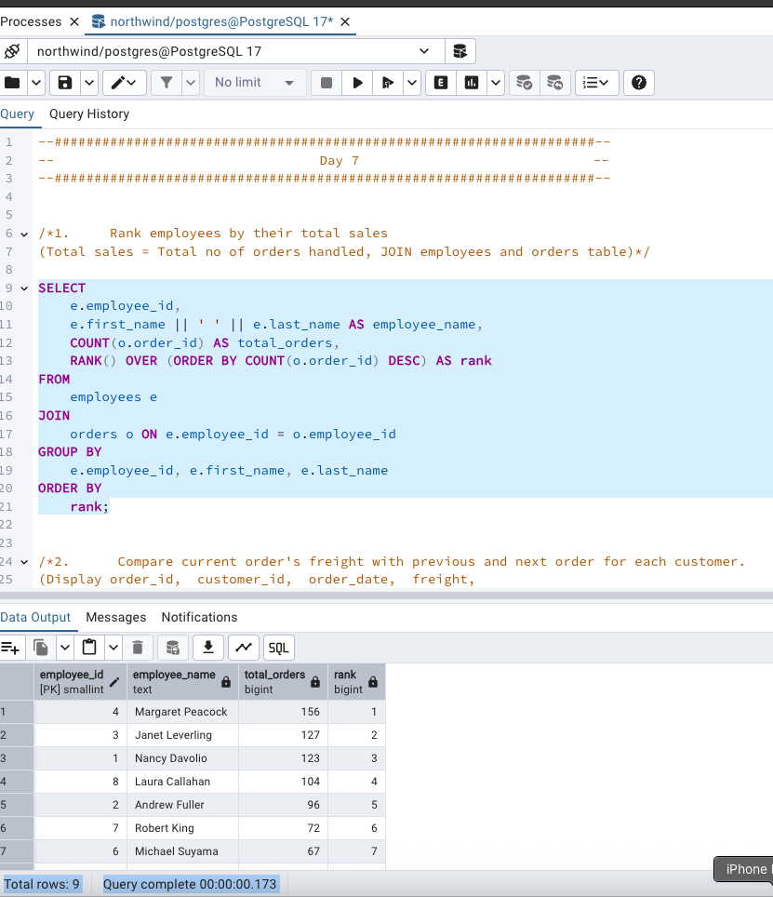

/*2. Compare current order's freight with previous and next order for each customer.

(Display order_id, customer_id, order_date, freight,

Use lead(freight) and lag(freight).*/

SELECT order_id, customer_id, order_date, freight,

LAG(freight) OVER (PARTITION BY customer_id ORDER BY order_date) AS previous_freight,

LEAD(freight) OVER (PARTITION BY customer_id ORDER BY order_date) AS next_freight

FROM orders

ORDER BY customer_id, order_date;

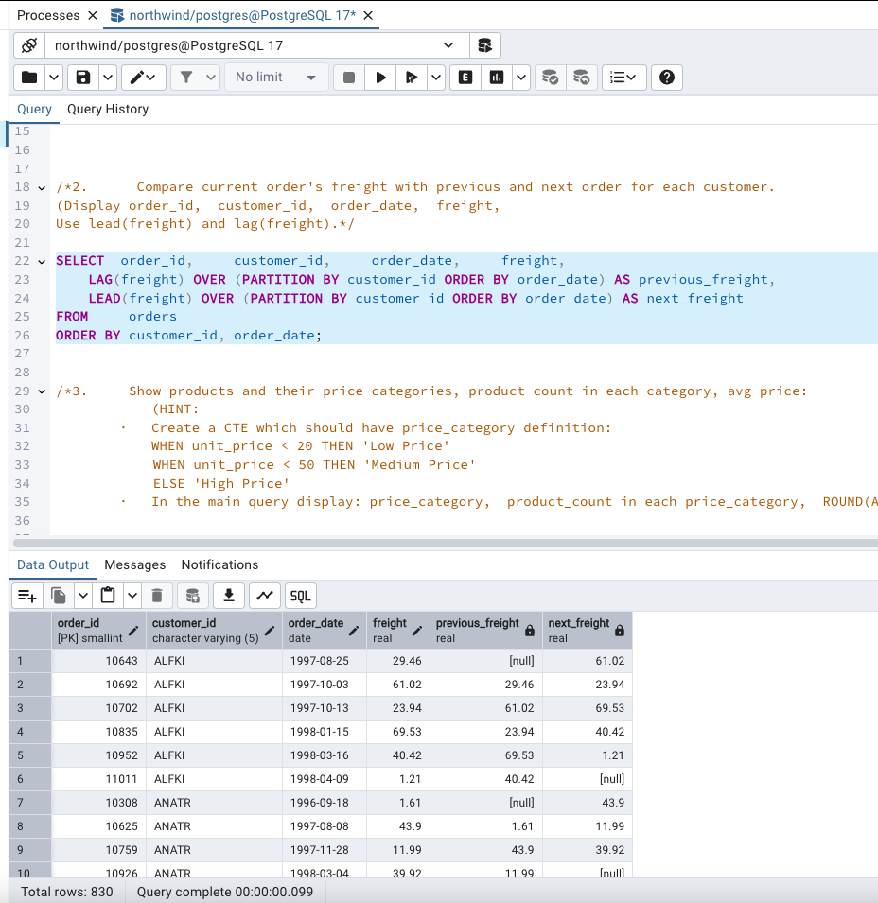

/*3. Show products and their price categories, product count in each category, avg price:

(HINT:

· Create a CTE which should have price_category definition:

WHEN unit_price < 20 THEN 'Low Price'

WHEN unit_price < 50 THEN 'Medium Price'

ELSE 'High Price'

· In the main query display: price_category, product_count in each price_category, ROUND(AVG(unit_price)::numeric, 2) as avg_price)*/

WITH product_prices AS (

SELECT product_name, unit_price,

CASE

WHEN unit_price < 20 THEN 'Low Price'

WHEN unit_price < 50 THEN 'Medium Price'

ELSE 'High Price'

END AS price_category

FROM products

)

SELECT price_category,

COUNT(*) AS product_count,

ROUND(AVG(unit_price)::numeric, 2) AS avg_price

FROM product_prices

GROUP BY price_category

ORDER BY avg_price;

